# WEEK 2: Exercise 3: Stored Procedures

## Scenario 1: Process Monthly Interest

The bank needs to process monthly interest for all savings accounts.  
Write a stored procedure ProcessMonthlyInterest that calculates and updates the balance of all savings accounts by applying an interest rate of 1% to the current balance.

**QUERY:**

CREATE OR REPLACE PROCEDURE ProcessMonthlyInterest IS  
BEGIN  
 FOR acc IN (SELECT AccountID, Balance FROM Accounts WHERE AccountType = 'Savings') LOOP  
 UPDATE Accounts  
 SET Balance = Balance + (acc.Balance * 0.01)  
 WHERE AccountID = acc.AccountID;  
   
 DBMS_OUTPUT.PUT_LINE('Interest applied to Account ID: ' || acc.AccountID);  
 END LOOP;  
   
 COMMIT;  
END;  
/

**OUTPUT:**

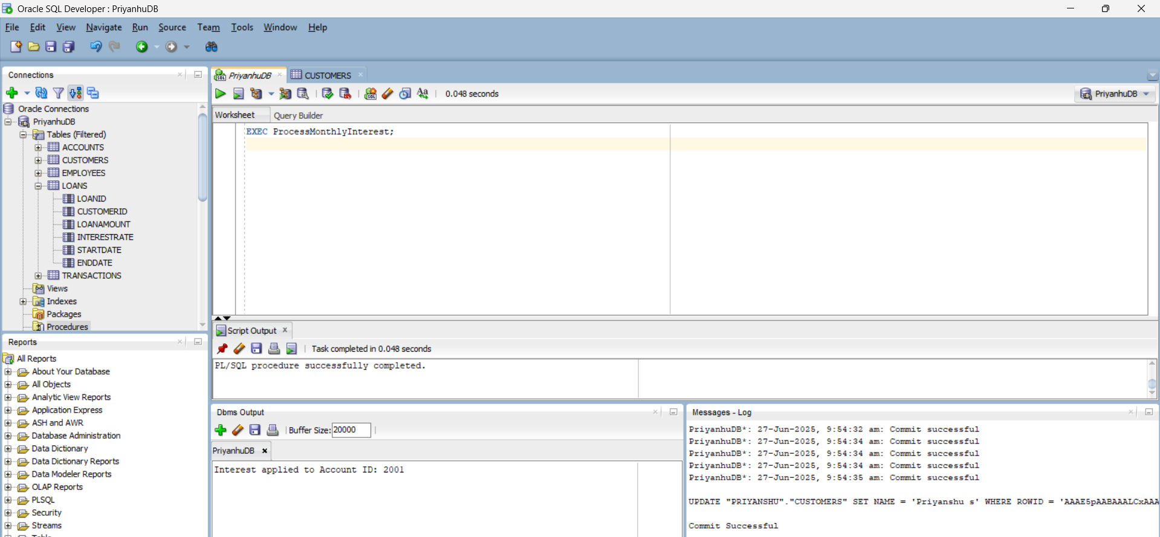

## Scenario 2: Update Employee Bonus

The bank wants to implement a bonus scheme for employees based on their performance.  
Write a stored procedure UpdateEmployeeBonus that updates the salary of employees in a given department by adding a bonus percentage passed as a parameter.

**QUERY:**

CREATE OR REPLACE PROCEDURE UpdateEmployeeBonus(  
 dept_name IN VARCHAR2,  
 bonus_percent IN NUMBER  
) IS  
BEGIN  
 FOR emp IN (SELECT EmployeeID, Salary FROM Employees WHERE Department = dept_name) LOOP  
 UPDATE Employees  
 SET Salary = Salary + (emp.Salary * bonus_percent / 100)  
 WHERE EmployeeID = emp.EmployeeID;  
   
 DBMS_OUTPUT.PUT_LINE('Bonus applied to Employee ID: ' || emp.EmployeeID);  
 END LOOP;  
   
 COMMIT;  
END;  
/

**OUTPUT:**

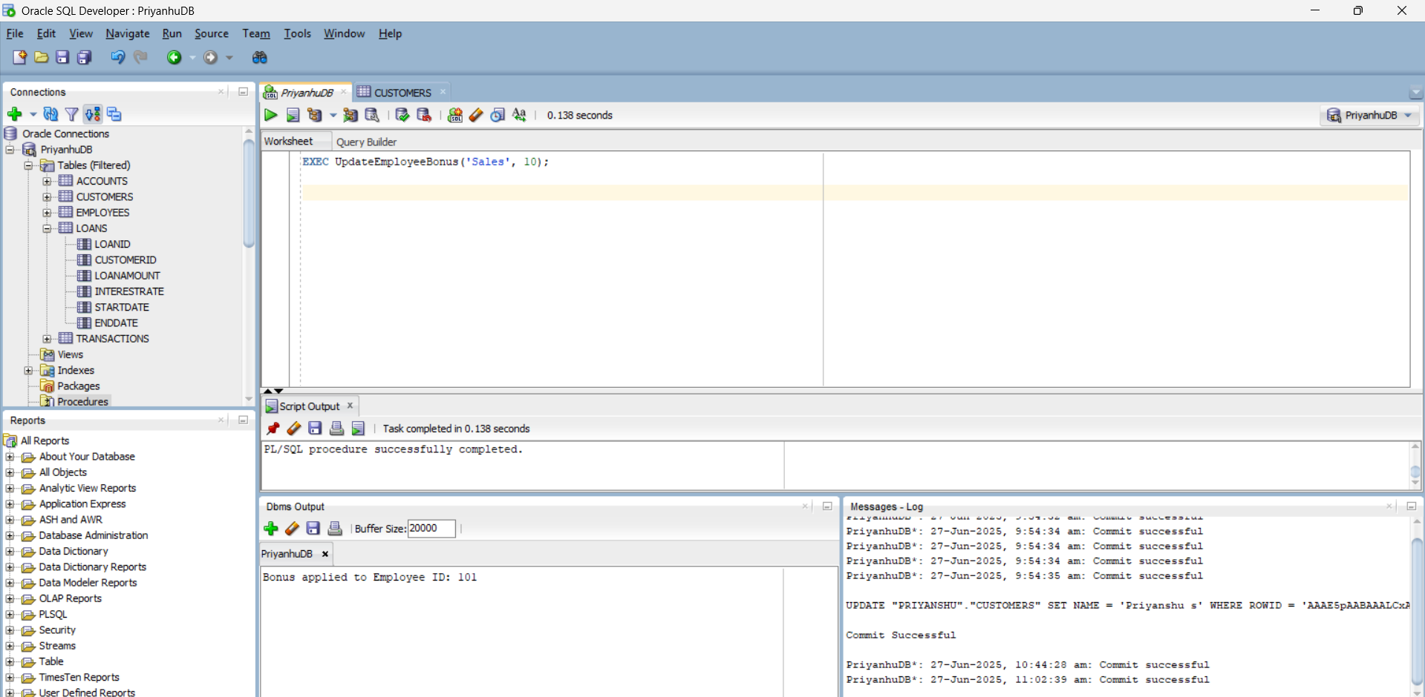

## Scenario 3: Transfer Funds Between Accounts

Customers should be able to transfer funds between their accounts.  
Write a stored procedure TransferFunds that transfers a specified amount from one account to another, checking that the source account has sufficient balance before making the transfer.

CREATE OR REPLACE PROCEDURE TransferFunds(  
 source_acc_id IN NUMBER,  
 dest_acc_id IN NUMBER,  
 amount IN NUMBER  
) IS  
 insufficient_balance EXCEPTION;  
BEGIN  
 DECLARE  
 src_balance NUMBER;  
 BEGIN  
 SELECT Balance INTO src_balance FROM Accounts WHERE AccountID = source_acc_id FOR UPDATE;  
   
 IF src_balance < amount THEN  
 RAISE insufficient_balance;  
 END IF;  
  
 UPDATE Accounts SET Balance = Balance - amount WHERE AccountID = source_acc_id;  
 UPDATE Accounts SET Balance = Balance + amount WHERE AccountID = dest_acc_id;  
  
 DBMS_OUTPUT.PUT_LINE( amount || ' transferred from Account ' || source_acc_id || ' to Account ' || dest_acc_id);  
 COMMIT;  
 END;  
  
EXCEPTION  
 WHEN insufficient_balance THEN  
 DBMS_OUTPUT.PUT_LINE('Transfer failed: Insufficient balance in Account ' || source_acc_id);  
 ROLLBACK;  
END;  
/

**OUTPUT:**

